**[Servo ABS again!](https://forum.hexcode.co.za/forum/index.php/topic,1667.msg6846.html" \l "msg6846)**

« **on:** May 29, 2017, 03:21:28 PM »

* [**Quote**](https://forum.hexcode.co.za/forum/index.php?action=post;quote=6846;topic=1667.0;last_msg=7184)

Hello,  
  
New here but thought I'd ask the question in case someone can help  :)  
  
Bike is 2006 R1200GS Adventure with the Servo assisted ABS brakes.   
  
2 months ago (after cleaning out the system and replacing a broken pressure switch) all working fine according to GS911 - during the tests all 4 circuits (front and rear control circuits and the front and rear wheel circuits) all showing between 17 and 20 bar of pressure during Sensor Drift Test. Also no faults in ABS fault history. Over next 2 months and 700 miles approx. no issues with the brakes at all.  
  
On a recent trip "brake failure" warning came up on a quiet stretch of motorway. Stopped the bike switched ignition off and on and fault cleared. When I got home checked the faults with the GS911 and the following faults came up:  
  
25165: Internal Control Module Error - main processor reset due to indervoltage  
24951: ABS motor rear, defective  
24971: Pressure in front wheel circuit to high  
  
In all 3 cases the faults are no longer present. Also rear ABS motor is working fine (whizzing away) and battery is new.  
  
However, front wheel circuit is showing a pressure of only 4 bar:  
  
and because of this Sensor Drift test will not run:  
  
I have bled and flushed the system through and there is no air in the system and the fluid is all clean. Can't see any leaks anywhere in the system and if I ride the bike all appears to function as normal (full strength brakes, no warning lights).  
  
My questions are:  
  
1. Why does bike (or the GS911) not give a constant error if the front wheel circuit pressure is low?  
2. Is it likely to be another faulty pressure switch in the ABS Servo unit or could it be something else?  
Or anyone have any orther ideas?  
[**mopedi**](https://forum.hexcode.co.za/forum/index.php?action=profile;u=2829)

[**Re: Servo ABS again!**](https://forum.hexcode.co.za/forum/index.php/topic,1667.msg7173.html#msg7173)

« **Reply #1 on:** August 30, 2017, 01:21:51 PM »

* [**Quote**](https://forum.hexcode.co.za/forum/index.php?action=post;quote=7173;topic=1667.0;last_msg=7184)

Did you perform braking at a time when you received brake failure indicator on instrument cluster? The best would be if you have GS911 with you when brake failure is present to read active errors (in red color) otherwise after power off/on this errors becomes in black color and you do not know when it happened.  
My real concern would be to a pressure sensor showing 4 bars at no brakes activated. This leads to failed or in near future failed pressure sensor. Existing original pressure sensors do fail without any announcement or predefined way! This sensors are not temperature compensated and would in healty status show ideally 20bar at 20degC, at 30degC the same sensor would show in range of 17bar and at 10degC it would show in range of 22bars. This pressure sensors are very sensitive and would most likely fail if you unscrew 5wing torx bolts from sensor support. Most often rear  wheel pressure sensor would fail to value above 30bar because of higher braking fluid pressure at rear wheel at braking process, this leads to rear wheel pressure modulation.  
The tricky part by purchasing used modulator with healty pressure sensors is that you do not know (and can not predict) how long pressure sensors will be ok.

[Report to moderator](https://forum.hexcode.co.za/forum/index.php?action=reporttm;topic=1667.1;msg=7173)   https://forum.hexcode.co.za/forum/Themes/default/images/ip.gif [Logged](https://forum.hexcode.co.za/forum/index.php?action=helpadmin;help=see_member_ip)

[**Hunda67**](https://forum.hexcode.co.za/forum/index.php?action=profile;u=2465)

[**Re: Servo ABS again!**](https://forum.hexcode.co.za/forum/index.php/topic,1667.msg7174.html#msg7174)

« **Reply #2 on:** August 30, 2017, 01:33:53 PM »

* [**Quote**](https://forum.hexcode.co.za/forum/index.php?action=post;quote=7174;topic=1667.0;last_msg=7184)

[**Quote from: mopedi on August 30, 2017, 01:21:51 PM**](https://forum.hexcode.co.za/forum/index.php/topic,1667.msg7173.html#msg7173)

Did you perform braking at a time when you received brake failure indicator on instrument cluster? The best would be if you have GS911 with you when brake failure is present to read active errors (in red color) otherwise after power off/on this errors becomes in black color and you do not know when it happened.  
My real concern would be to a pressure sensor showing 4 bars at no brakes activated. This leads to failed or in near future failed pressure sensor. Existing original pressure sensors do fail without any announcement or predefined way! This sensors are **not temperature compensated and would in healty status show ideally 20bar at 20degC, at 30degC the same sensor would show in range of 17bar and at 10degC it would show in range of 22bars.**

This pressure sensors are very sensitive and would most likely fail if you unscrew 5wing torx bolts from sensor support. Most often rear  wheel pressure sensor would fail to value above **30bar because of higher braking fluid pressure at rear wheel at braking process, this leads to rear wheel pressure modulation.**

The tricky part by purchasing used modulator with healty pressure sensors is that you do not know (and can not predict) how long pressure sensors will be ok.

I think that's it - I took sensors from a second hand unit and whilst working for a few weeks one must have since failed. Since first posting I have removed the servo system and am quite happy without abs/servos. I would put the servos and ABS back but only if I can source some new ones.  
  
Sent from my SM-G920F using Tapatalk

[Report to moderator](https://forum.hexcode.co.za/forum/index.php?action=reporttm;topic=1667.2;msg=7174)   https://forum.hexcode.co.za/forum/Themes/default/images/ip.gif [Logged](https://forum.hexcode.co.za/forum/index.php?action=helpadmin;help=see_member_ip)

[**mopedi**](https://forum.hexcode.co.za/forum/index.php?action=profile;u=2829)

[**Re: Servo ABS again!**](https://forum.hexcode.co.za/forum/index.php/topic,1667.msg7175.html#msg7175)

« **Reply #3 on:** August 30, 2017, 02:00:11 PM »

* [**Quote**](https://forum.hexcode.co.za/forum/index.php?action=post;quote=7175;topic=1667.0;last_msg=7184)

I perform replacement of pressure sensors with custom made ones, temperature and aging compensated. The replacement requires new sensor holder, some machining on modulator body to accomodate new sealing o-ring. The solution I implemented on at least 40 servo modulators with 3 years of experience. The solution is similar to RH Electronics solution but for half a price.

[Report to moderator](https://forum.hexcode.co.za/forum/index.php?action=reporttm;topic=1667.3;msg=7175)   https://forum.hexcode.co.za/forum/Themes/default/images/ip.gif [Logged](https://forum.hexcode.co.za/forum/index.php?action=helpadmin;help=see_member_ip)

[**Hunda67**](https://forum.hexcode.co.za/forum/index.php?action=profile;u=2465)

[**Re: Servo ABS again!**](https://forum.hexcode.co.za/forum/index.php/topic,1667.msg7178.html#msg7178)

« **Reply #4 on:** August 30, 2017, 04:36:24 PM »

* [**Quote**](https://forum.hexcode.co.za/forum/index.php?action=post;quote=7178;topic=1667.0;last_msg=7184)

[**Quote from: mopedi on August 30, 2017, 02:00:11 PM**](https://forum.hexcode.co.za/forum/index.php/topic,1667.msg7175.html#msg7175)

**I perform replacement of pressure sensors with custom made ones, temperature and aging compensated. The replacement requires new sensor holder, some machining on modulator body to accomodate new sealing o-ring. The solution I implemented on at least 40 servo modulators with 3 years of experience. The solution is similar to RH Electronics solution but for half a price.**

That's interesting to know. So what is your cost for overhauling the sensors? Do you need the whole ABS unit or just the two plates with the pressure switches?  
  
Sent from my SM-G920F using Tapatalk

[**mopedi**](https://forum.hexcode.co.za/forum/index.php?action=profile;u=2829)

[**Re: Servo ABS again!**](https://forum.hexcode.co.za/forum/index.php/topic,1667.msg7180.html#msg7180)

« **Reply #5 on:** August 30, 2017, 08:00:09 PM »

* [**Quote**](https://forum.hexcode.co.za/forum/index.php?action=post;quote=7180;topic=1667.0;last_msg=7184)

For repair whole modulator is required to check pumps, valves and motors and fitting new o-rings. I can attach some pictures if interested. The repair is in range of 400-500eur depends on what I receive and if modulator was opened/repaired before, specially if all 4 pressure sensors were removed ( that means all 4 are dead!) from housing.

[**Hunda67**](https://forum.hexcode.co.za/forum/index.php?action=profile;u=2465)

[**Re: Servo ABS again!**](https://forum.hexcode.co.za/forum/index.php/topic,1667.msg7181.html#msg7181)

« **Reply #6 on:** August 30, 2017, 08:13:29 PM »

* [**Quote**](https://forum.hexcode.co.za/forum/index.php?action=post;quote=7181;topic=1667.0;last_msg=7184)

[**Quote from: mopedi on August 30, 2017, 08:00:09 PM**](https://forum.hexcode.co.za/forum/index.php/topic,1667.msg7180.html#msg7180)

For repair whole modulator is required to check pumps, valves and motors and fitting new o-rings. I can attach some pictures if interested. The repair is in range of 400-500eur depends on what I receive and if modulator was opened/repaired before, specially if all 4 pressure sensors were removed ( that means all 4 are dead!) from housing.

All 4 sensors were removed but left on the mounting plate like this: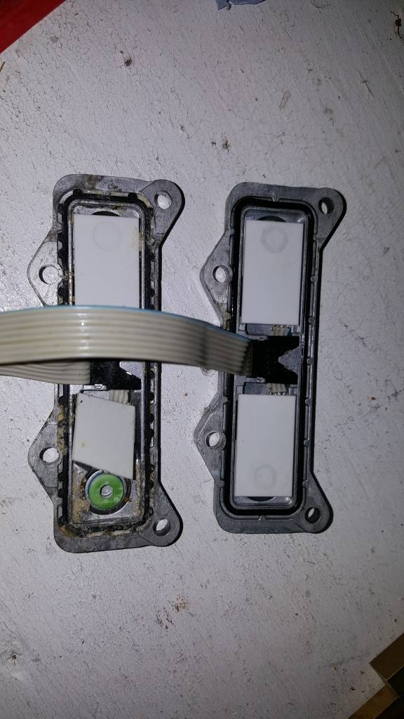

I replaced the broken switch as a pair from a second hand ABS unit - I did not remove the switches from mounting plate.  
I think if you have a source for these switches you could make a good business selling them https://emoji.tapatalk-cdn.com/emoji6.png   
Some pictures would be interesting.  
Sent from my SM-G920F using Tapatalk

[**Re: Servo ABS again!**](https://forum.hexcode.co.za/forum/index.php/topic,1667.msg7183.html#msg7183)

« **Reply #7 on:** August 30, 2017, 10:54:55 PM »

* [**Quote**](https://forum.hexcode.co.za/forum/index.php?action=post;quote=7183;topic=1667.0;last_msg=7184)

As I can see you removed all 4 sensors. Yo can connect sensors to electronics and with GS911 you may check their operability. You may expect one or both of motors running depends how many are dead ( **above 30bar or below 10bar**. I would not install them because even good ones will fail soon.  
  
In attached pictures please find some parts of new sensors, new housing and modified o-ring installation. Because of small number of sensors and mounting plate ordered this items are expensive specially sensors which are custom made by my spec.

https://forum.hexcode.co.za/forum/Themes/default/images/post/xx.gif

[**Re: Servo ABS again!**](https://forum.hexcode.co.za/forum/index.php/topic,1667.msg7184.html#msg7184)

« **Reply #8 on:** August 31, 2017, 06:37:08 AM »

* [**Quote**](https://forum.hexcode.co.za/forum/index.php?action=post;quote=7184;topic=1667.0;last_msg=7184)

sorry  but server reported me error when I attach pictures. I will try to do them today.

**Diameter originele sensor is ongeveer 8mm** the breedte van het plaatje buiten kant zonder oren is 26 mm